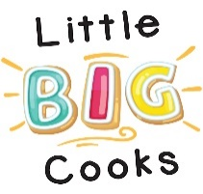
Thank you for taking part in my qualitative research which is to investigate the effect of parent-child cooking on the parent-child relationship.
Please will you be honest with the answers, and please let your child answer in that special way that only children can.

Children’s Questions:
- How did cooking with your mum/dad/family-member make you feel?

- Why does it make you that way?

- What did you like about cooking with your mum/dad/family member?

- Would you want to do this on a regular basis, if so why?

Adult Questions:
- Did you enjoy cooking with your son/daughter, and if so why?

- Do you feel closer to your child as a result, if so in what way?

- Did you feel your son/daughter learnt anything from cooking with you, and if so what did you feel they did learn?

- Would you want to do this on a regular basis, if so why, and how would it benefit?

- Is there anything else that you would like to add about this experiment?

